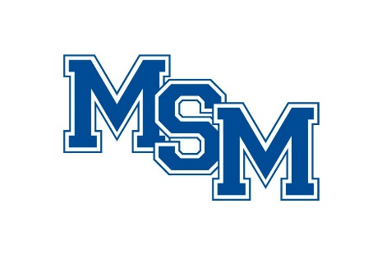
2021 Summer Pride Camp Waiver of Liability

I certify that my child has been examined by a physician and found to be in good health and able to compete in all athletic activities without restriction. I acknowledge that I have medical insurance to cover the cost of any injury or illness that may occur during my camper/student’s participation in any athletic activities. I authorize Mount St. Mary Catholic High School and members of its staff or the camp staff to act for me and use their best judgment in any emergency requiring medical attention. I acknowledge that any athletic event is an inherently dangerous activity that can cause personal injuries due to contact or non-contact athletic activity. I hereby release Mount St. Mary Catholic High School, Mount St. Mary Catholic High School Athletic Staff, Mount St. Mary Catholic High School Camp Staff and any other agent or employee of Mount St. Mary Catholic High School from any and all liability, claims, demands, or causes of action that I may hereafter have for injuries or damages arising during my camper/student’s participation in athletic activities.

__________________________________
Parent/Guardian Name (Printed)

__________________________________
Parent/Guardian Signature

__________________________________
Date

