ROCKET SPORTS UPDATES BY THE SPORTS INFORMATION DEPARTMENT

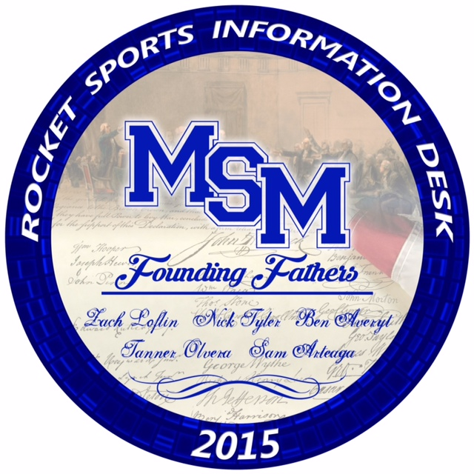

VOLLEYBALL UPDATE BY AUBREY HADDON 27 SEPTEMBER 2016

This past weekend our Rocket volleyball team traveled to the CHA gym to play in the Chisholm

Trail Conference Tournament. The team went undefeated in regular conference season play,

winning their conference for the first time in Mount St. Mary volleyball history. There are 7 teams

included in the Chisholm Trail Conference: Bethany, Christian Heritage Academy, Community

Christian School, Heritage Hall, Oklahoma Christian School, Oklahoma Bible Academy, and our

Mount St. Mary Rockets. The team went undefeated in pool play, ranking them #1 going into

bracket play. The girls beat Community Christian School in the semi-finals. They then went on

to play Christian Heritage Academy for the final game. The girls fought hard and came out on

top, winning the game 3-1. For the first time ever, the rocket volleyball team won their

Conference and their conference tournament. Things are looking good for the team as they

continue on their journey to winning a State title. Keep working, girls!

SOFTBALL END OF SEASON WRAP UP BY LIZ CORDOVA
20 SEPTEMBER 2016

Lady Rockets ended the season with two losses to Jones in District play this past Tuesday. They played ferociously both games and gave them their all. A number of fans, including students, came out to watch the Lady Rockets that evening. The whole ballpark was buzzing with excitement and energy. We had Senior Night after the game and said thank you and goodbye to Elizabeth Cordova, Cheyenne Harwood and Kynsington Cochrane. With the smell of the Reynold's grill cooking burgers and hot dogs, and the sound of Coach Keilty’s voice of the PA, the rockets were ready to play that evening. Your Lady Rockets had a rough year but never gave up. They worked hard all season and improved till the last out of the season. We had an amazing senior night after the games. We wish the best of luck to Liz Cordova who hopes to play softball at the next level. A big thank you to Dominic Randall, Sean Lipps, Chris Robinson, and Austin Copeland for coming out and cheering loudly for the Lady Rockets. Your Lady Rockets Softball wanted to say thank you to the coaching staff for having the patience and ability to help them throughout the season. They made a lot of memories and cannot wait till next season begins. GO ROCKETS!!!!

__________________________________________________________________________________________________________________________________________________________________________________________________________________________________________
VOLLEYBALL UPDATE BY AUBREY HADDON 22 SEP 2016

The month of September has been a busy month for our Rocket Volleyball Girls. They have had

10 games so far, coming out on top for 8 of them. They defeated Bethany in an easy 3 sets on

September 1. Then on September 6, our school celebrated the four volleyball seniors, Morgan

Foley, Aubrey Haddon Cohlmia, Jill Ruhl, and Yareli Ruelas during senior ceremonies before

the game against Heritage Hall started. The seniors and the rest of the team came out strong

and ready to play, beating the Chargers in 3 sets. The weekend of the 10th, the team had a

tournament at Santa Fe High School where they would be playing some of the best teams in

6A. Unfortunately, earlier in the week one of the starting players injured her ankle and wasn’t

able to play in the tournament. The team adjusted well to the loss of an important player and

ended up getting 5th in the tournament, defeating Bishop McGuinness twice in one weekend!

Senior Jill Ruhl was awarded a spot on the All-Tournament team.

The next week the Rockets defeated Oklahoma Christian School in 3 sets and Community

Christian School in 4 sets. Coach Jekel and her girls are continuing to work hard toward the

goal of winning 5A state. We can’t wait to see what the team achieves during the remaining

part of their season.

____________________________________________________________________________________________________________________________________________________________________________________________________________________________________

CROSS COUNTRY UPDATE BY SAM ARTEAGA AND ROSIE GATCH 10 SEP 2016

The Mount St. Mary boys and girls cross country teams had a spectacular day at Kingfisher

battling the difficult conditions of mud and cold water from the rain the night before. The boys

team finished 3rd with Bennett Barnett (11th grade) earning another 1st place finish while

Christian Yabut (10th grade) earned a 9th place finish. Garrett Kinsey (12th grade) earned a

13th place finish and Nick Parizek (11th grade) earned a 23rd place finish. All of them received

Medals and it was a great team effort overall. The girls team finished 4th with Gabby Sanderson

(10th grade) earning a 7th place finish overall. Kylie Dowers (11th grade) also finished 18th and

Reagan Ingram (11th grade) finished 20th. All of them received medals and it was a great team

effort. The Rockets will run next at the conference meet in Harrah on Tuesday, September 13th.

CROSS COUNTRY UPDATE –WATONGA BY GARRETT KINSEY AND ROSIE GATCH 4 SEP 2016

The Mount St. Mary Rockets Boys and Girls cross country team competed on Saturday,

September 3rd at Watonga. The Rocket Boy’s cross country team placed fourth out of twelve

teams in Watonga and they were within two points of taking third place. The Girl’s team placed

sixth out of nine teams. Gabby Sanderson was the first to cross the finish line.

The girls ran a 2k which is 1.2 miles shorter than what the girls usually run. The girl’s

usually run a two mile rather than a 2k. The Rocket boys were led by Bennett Barnett winning

first place. Bennett beat out the second place competitor by 0.6 seconds.

__________________________________________________________________________________________________________________________________________________________________________________________________________________________________________
FOOTBALL UPDATE –KINGFISHER BY WILL POLITTE 27 SEP 2016

The Rocket football team had a tough game against Kingfisher. Even with the Rocket’s best

effort, Kingfisher came out on top. Although, several members of the team had really good
games. Offensively, Chris Robinson (senior), scored the first touchdown for the Rockets with an

83-yard run after recovering a Kingfisher fumble. Austin Copeland (Senior) was tackled at the 3-

yard line after a 69 yard reception from Tanner Wade (Junior). On the same drive, Dylan Faires

(Senior) rushed into the end zone for Mount Mt. Mary’s second touchdown. As for defense, there

were just as many great performances. The Rocket defence had a total of 77 tackles, led by Jacob

Loflin (Sophomore) with 15 and Stuart Mayfield (senior). Jacob Loflin also had an interception.

The Rockets will be in action Friday night, against Centennial at Taft Stadium.

FOOTBALL UPDATE –BETHEL BY KOLLIN MOSELEY 22 SEP 2016

Last Friday night the rockets made a statement. They were at a crossroads

following their loss to CHA. With their backs against the wall the team made the

collective decision to fight on. With an attack of pure speed and determination the

Rockets played their most complete game this year. Senior Sean Lipps was able to

use his athletic ability to block a punt, which helped fuel the Rockets offense.

Dylan Faires spearheaded the offensive attack with 2 rushing touchdowns. The

Rockets emerged victorious against Bethel by a score of 28-6. They will be at

home against Kingfisher on Friday the 23rd.

FOOTBALL UPDATE- CHA BY WILL POLITTE 10 SEP 2016

The Rockets had their home opener Friday, September 9th before a packed crowd at Father

Fulton Field. Unfortunately, the Rockets came up short, but there was no question that the effort

was there. The final score was 31-14. Stuart Mayfield scored the first touchdown of the game

with a five yard run, followed by Dylan Faires’ thirty-one yard rushing TD. Many different

players had a big impact on the game, one was senior Chris Robinson. He led the team in rushing

with a total of 94 yards in just eleven carries. Faires and Mayfield led the defense with fifteen

and ten tackles each. Andrew Percifield and Jacob Rossow each had a sack. With many strong

Performances with many different players, the Rockets are excited for their next game this

Friday against Bethel at home and are ready to bounce back.

FOOTBALL UPDATE –CROOKED OAK BY RILEY LOWRY 4 SEP 2016

On 2 September, Mount St. Mary’s kicked off their football season against Crooked Oak High School at Crooked Oak. The game was nothing short of exciting and fun to watch. The final score was 45-13 with Mount St. Mary coming out on top. It was an impressive win on both sides of the ball. Leading us to victory was the new quarterback Tanner Wade. Tanner was very impressive Friday passing for 200 yards which may be a new school record. The receiving end of many of these passes was Timothy “ Timo “ Keupen. Timothy caught two touchdown passes. Timo was also the kicker. The other receiver was Jacob Loflin, who even though didn’t catch any touchdown passes this game, is looking forward for the opportunities to come.
Now to jump forward to next Friday’s game, Coach Perkins had some

words, “Everyone says that this game is our rivalry, to me this isn’t a rivalry

till we beat these guys” . Coach Perkins added that they are 0-4 against

CHA and they need to win this game so that they can make a statement.

He really emphasized that the team is really ready to get out there and

show, once again, what they are made of.

